SQL Queries

**Q-1) create table students and exam**

Query:

1. *Creating ‘students’ table:*

create table students (Rollno int primary key, name varchar(100), branch varchar(100));

1. *Creating ‘exam’ table:*

create table exam (Rollno int, S_code varchar(10), Marks int, P_code varchar(10), foreign key (Rollno) REFERENCES student (Rollno));

1. *Inserting data into ‘student’ table:*

INSERT INTO `students`(`Rollno`, `name`, `branch`) VALUES

('1', 'Jay', 'Computer Science'),

('2', 'Suhani', 'Electronic and com'),

('3', 'Kriti', 'Electronic and com');

1. *Inserting data into ‘exam’ table:*

INSERT INTO `exam`(`Rollno`, `S_code`, `Marks`, `P_code`)

VALUES

('1','CS111','50','CS'),

('1','CS112','60','CS'),

('2','EC101','66','EC'),

('2','EC102','70','EC'),

('3','EC101','45','EC'),

('3','EC102','50','EC');

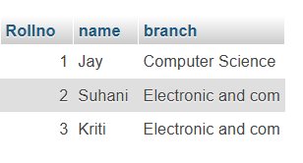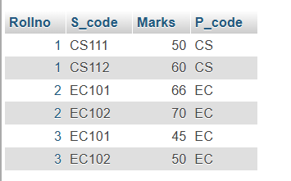

**Q-2) Create table employee and incentive:**

Queries:-

1. *Creating ‘employee’ table:*

create table Employee (Employee_id int primary key, first_name varchar(100), last_name varchar(100), salary decimal (10,2), joining_date datetime, department varchar(100));

1. *Creating ‘incentive’ table:*

create table Incentive (Employee_ref_id int, incentive_date date, incentive_amount decimal(10,2), foreign key (Employee_ref_id) references employee (Employee_id));

1. *Inserting data into ‘employee’ table:*

INSERT INTO `employee`(`Employee_id`, `first_name`, `last_name`, `salary`, `joining_date`, `department`) VALUES

('1', 'John ', 'Abraham', '1000000', '2013-01-01 12:00:00', 'Banking'),

('2', 'Michael', 'Clarke', '800000', '2013-01-01 12:00:00', 'Insurance'),

('3', 'Roy', 'Thomas', '700000', '2013-01-01 12:00:00', 'Banking'),

('4', 'Tom', 'Jose', '800000', '2013-02-01 12:00:00', 'Insurance'),

('5', 'Jerry', 'Pinto', '650000', '2013-02-01 12:00:00', 'Insurance'),

('6', 'Philip', 'Mathew', '750000', '2013-01-01 12:00:00', 'Services'),

('7', 'TestName1', '123', '650000', '2013-01-01 12:00:00', 'Services'),

('8', 'TestName2', 'Lname', '600000', '2013-02-01 12:00:00', 'Insurance');

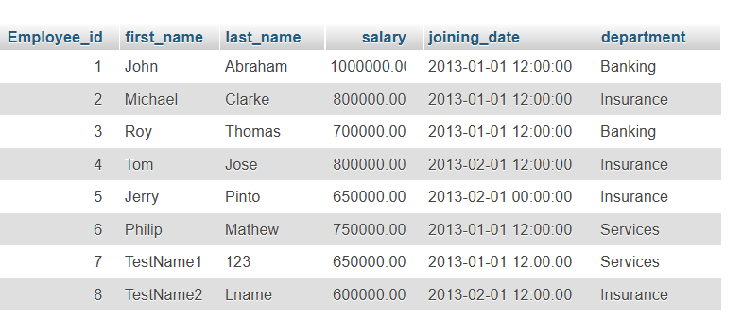

1. *Inserting data into ‘incentive’ table:*

INSERT INTO `incentive`(`Employee_ref_id`, `incentive_date`, `incentive_amount`)

VALUES

('1','2013-02-01','5000'),

('2','2013-02-01','3000'),

('3','2013-02-01','4000'),

('1','2013-01-01','4500'),

('2','2013-01-01','3500');

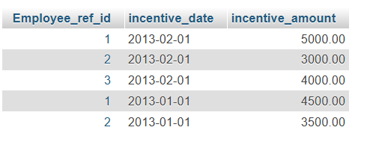

1. *Get First_Name from ‘employee’ table using ‘****Tom’*** *name “Employee Name”:*

Query:-

SELECT first_name FROM `employee` WHERE first_name = 'Tom';

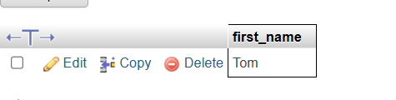

1. *Get FIRST_NAME, Joining Date, and Salary from ‘employee’ table:*

Query:-

SELECT first_name, joining_date, salary FROM `employee`;

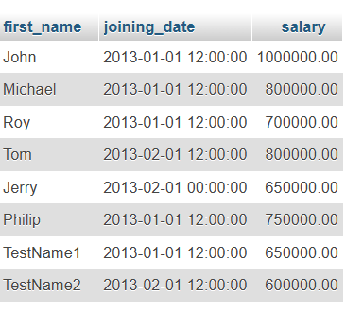

1. *Get all employee details from ‘employee’ table ordered by first_name ascending and salary descending:*

Query:-

SELECT * FROM `employee` order by first_name asc, salary desc;

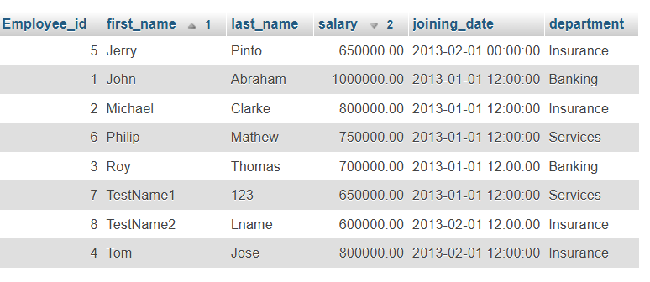

1. *Get employee details from ‘employee’ table whose first name contains* ***‘J’****.*

Query:-

SELECT * FROM `employee` WHERE first_name like '%J%';

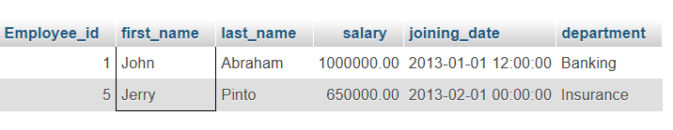

1. *Get department wise maximum salary from the ‘employee’ table and order by salary ascending:*

Query:-

SELECT `department`, MAX(salary) as Max_Salary FROM `employee`

group by department

order by Max_Salary asc;

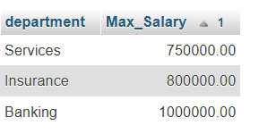

1. *Select first_name, incentive amount from ‘employee’ and ‘incentives’ table for those employees who have incentives and incentive amount greater than 3000:*

Query:-

SELECT e.first_name, i.incentive_amount from employee e join incentive i on e.Employee_id = i.Employee_ref_id where i.incentive_amount > 3000;

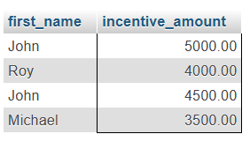

1. *Create After Insert trigger on ‘Employee’ table which insert records in view table:*

Query:-

CREATE TABLE ViewTable (Employee_id INT, First_name VARCHAR(100), Last_name VARCHAR(100), Inserted_at DATETIME);

DELIMITER $$

CREATE TRIGGER after_employee_insert AFTER INSERT ON Employee

FOR EACH ROW

BEGIN

INSERT INTO ViewTable (Employee_id, First_name, Last_name, Inserted_at)

VALUES (NEW.Employee_id, NEW.First_name, NEW.Last_name, NOW());

END $$

INSERT INTO Employee (Employee_id, First_name, Last_name, Salary, Joining_date, Department) VALUES

(9, 'dead', 'pool', 50000.00, '2001-02-01', 'HR'),

(10, 'raj', 'pandhi', 60000.00, '2002-02-01', 'sales');

select * from ViewTable;

